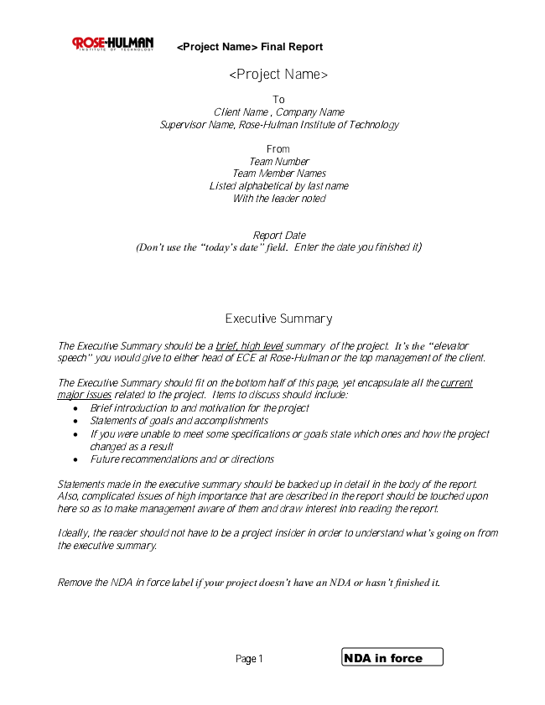

**<Project Name> Final Report**

**<Project Name>**

*To Client Name , Company Name Supervisor Name, Rose-Hulman Institute of Technology*

*From Team Number Team Member Names Listed alphabetical by last name With the leader noted*

*Report Date (Don’t use the “today’s date” field. Enter the date you finished it)*

**Executive Summary**

*The Executive Summary should be a brief, high level summary of the project. It’s the “elevator speech” you would give to either head of ECE at Rose-Hulman or the top management of the client.*

*The Executive Summary should fit on the bottom half of this page, yet encapsulate all the current major issues related to the project. Items to discuss should include:*

*• Brief introduction to and motivation for the project*

*• Statements of goals and accomplishments*

*• If you were unable to meet some specifications or goals state which ones and how the project changed as a result*

*• Future recommendations and or directions*

*Statements made in the executive summary should be backed up in detail in the body of the report. Also, complicated issues of high importance that are described in the report should be touched upon here so as to make management aware of them and draw interest into reading the report.*

*Ideally, the reader should not have to be a project insider in order to understand what’s going on from the executive summary.*

*Remove the NDA in force label if your project doesn’t have an NDA or hasn’t finished it.*

Page 1 NDA in force

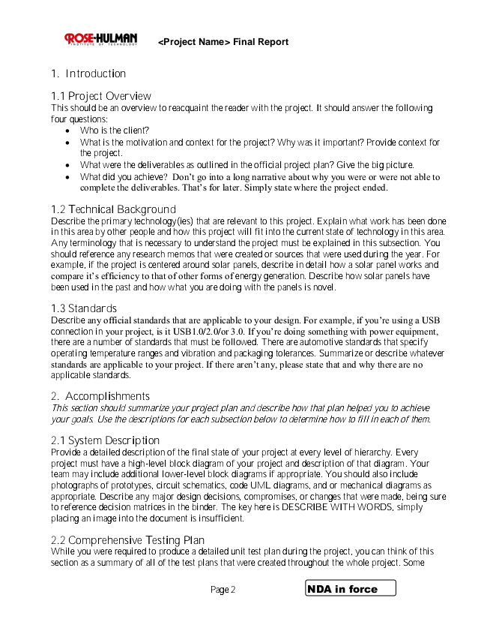

**<Project Name> Final Report**

**1. Introduction**

1.1 Project Overview This should be an overview to reacquaint the reader with the project. It should answer the following four questions:

• Who is the client?

• What is the motivation and context for the project? Why was it important? Provide context for the project.

• What were the deliverables as outlined in the official project plan? Give the big picture.

• What did you achieve? Don’t go into a long narrative about why you were or were not able to complete the deliverables. That’s for later. Simply state where the project ended.

1.2 Technical Background Describe the primary technology(ies) that are relevant to this project. Explain what work has been done in this area by other people and how this project will fit into the current state of technology in this area. Any terminology that is necessary to understand the project must be explained in this subsection. You should reference any research memos that were created or sources that were used during the year. For example, if the project is centered around solar panels, describe in detail how a solar panel works and compare it’s efficiency to that of other forms of energy generation. Describe how solar panels have been used in the past and how what you are doing with the panels is novel.

1.3 Standards Describe any official standards that are applicable to your design. For example, if you’re using a USB connection in your project, is it USB1.0/2.0/or 3.0. If you’re doing something with power equipment, there are a number of standards that must be followed. There are automotive standards that specify operating temperature ranges and vibration and packaging tolerances. Summarize or describe whatever standards are applicable to your project. If there aren’t any, please state that and why there are no applicable standards.

*2. Accomplishments This section should summarize your project plan and describe how that plan helped you to achieve your goals. Use the descriptions for each subsection below to determine how to fill in each of them.*

2.1 System Description Provide a detailed description of the final state of your project at every level of hierarchy. Every project must have a high-level block diagram of your project and description of that diagram. Your team may include additional lower-level block diagrams if appropriate. You should also include photographs of prototypes, circuit schematics, code UML diagrams, and or mechanical diagrams as appropriate. Describe any major design decisions, compromises, or changes that were made, being sure to reference decision matrices in the binder. The key here is DESCRIBE WITH WORDS, simply placing an image into the document is insufficient.

2.2 Comprehensive Testing Plan While you were required to produce a detailed unit test plan during the project, you can think of this section as a summary of all of the test plans that were created throughout the whole project. Some

Page 2 NDA in force

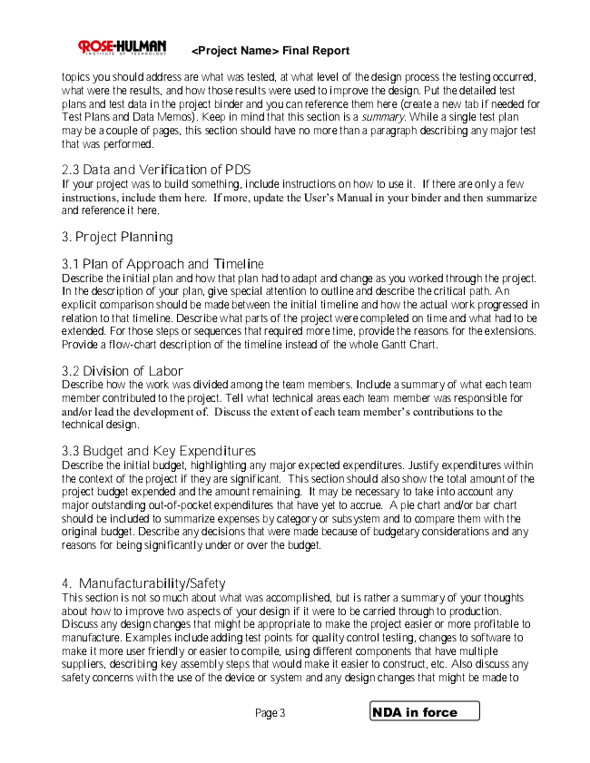

**<Project Name> Final Report**

topics you should address are what was tested, at what level of the design process the testing occurred, what were the results, and how those results were used to improve the design. Put the detailed test plans and test data in the project binder and you can reference them here (create a new tab if needed for Test Plans and Data Memos). Keep in mind that this section is a summary. While a single test plan may be a couple of pages, this section should have no more than a paragraph describing any major test that was performed.

2.3 Data and Verification of PDS If your project was to build something, include instructions on how to use it. If there are only a few instructions, include them here. If more, update the User’s Manual in your binder and then summarize and reference it here.

**3. Project Planning**

3.1 Plan of Approach and Timeline Describe the initial plan and how that plan had to adapt and change as you worked through the project. In the description of your plan, give special attention to outline and describe the critical path. An explicit comparison should be made between the initial timeline and how the actual work progressed in relation to that timeline. Describe what parts of the project were completed on time and what had to be extended. For those steps or sequences that required more time, provide the reasons for the extensions. Provide a flow-chart description of the timeline instead of the whole Gantt Chart.

3.2 Division of Labor Describe how the work was divided among the team members. Include a summary of what each team member contributed to the project. Tell what technical areas each team member was responsible for and/or lead the development of. Discuss the extent of each team member’s contributions to the technical design.

3.3 Budget and Key Expenditures Describe the initial budget, highlighting any major expected expenditures. Justify expenditures within the context of the project if they are significant. This section should also show the total amount of the project budget expended and the amount remaining. It may be necessary to take into account any major outstanding out-of-pocket expenditures that have yet to accrue. A pie chart and/or bar chart should be included to summarize expenses by category or subsystem and to compare them with the original budget. Describe any decisions that were made because of budgetary considerations and any reasons for being significantly under or over the budget.

4. Manufacturability/Safety This section is not so much about what was accomplished, but is rather a summary of your thoughts about how to improve two aspects of your design if it were to be carried through to production. Discuss any design changes that might be appropriate to make the project easier or more profitable to manufacture. Examples include adding test points for quality control testing, changes to software to make it more user friendly or easier to compile, using different components that have multiple suppliers, describing key assembly steps that would make it easier to construct, etc. Also discuss any safety concerns with the use of the device or system and any design changes that might be made to

Page 3 NDA in force

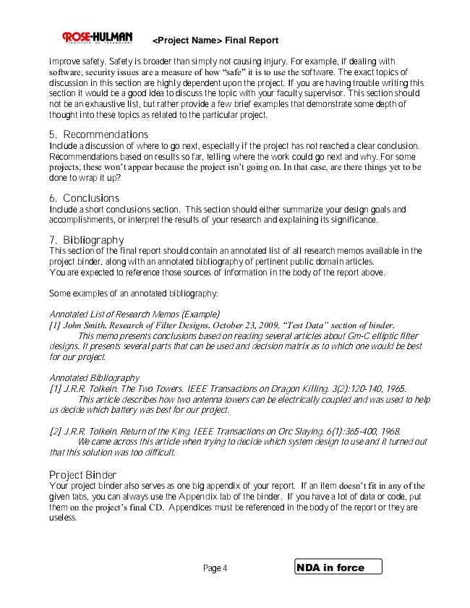

**<Project Name> Final Report**

improve safety. Safety is broader than simply not causing injury. For example, if dealing with software, security issues are a measure of how “safe” it is to use the software. The exact topics of discussion in this section are highly dependent upon the project. If you are having trouble writing this section it would be a good idea to discuss the topic with your faculty supervisor. This section should not be an exhaustive list, but rather provide a few brief examples that demonstrate some depth of thought into these topics as related to the particular project.

5. Recommendations Include a discussion of where to go next, especially if the project has not reached a clear conclusion. Recommendations based on results so far, telling where the work could go next and why. For some projects, these won’t appear because the project isn’t going on. In that case, are there things yet to be done to wrap it up?

6. Conclusions Include a short conclusions section. This section should either summarize your design goals and accomplishments, or interpret the results of your research and explaining its significance.

7. Bibliography This section of the final report should contain an annotated list of all research memos available in the project binder, along with an annotated bibliography of pertinent public domain articles. You are expected to reference those sources of information in the body of the report above.

Some examples of an annotated bibliography:

*Annotated List of Research Memos (Example) [1] John Smith. Research of Filter Designs. October 23, 2009. “Test Data” section of binder.*

*This memo presents conclusions based on reading several articles about Gm-C elliptic filter designs. It presents several parts that can be used and decision matrix as to which one would be best for our project.*

*Annotated Bibliography [1] J.R.R. Tolkein. The Two Towers. IEEE Transactions on Dragon Killing. 3(2):120-140, 1965.*

*This article describes how two antenna towers can be electrically coupled and was used to help us decide which battery was best for our project.*

*[2] J.R.R. Tolkein. Return of the King. IEEE Transactions on Orc Slaying. 6(1):365-400, 1968.*

*We came across this article when trying to decide which system design to use and it turned out that this solution was too difficult.*

Project Binder Your project binder also serves as one big appendix of your report. If an item doesn’t fit in any of the given tabs, you can always use the Appendix tab of the binder. If you have a lot of data or code, put them on the project’s final CD. Appendices must be referenced in the body of the report or they are useless.

Page 4 NDA in force

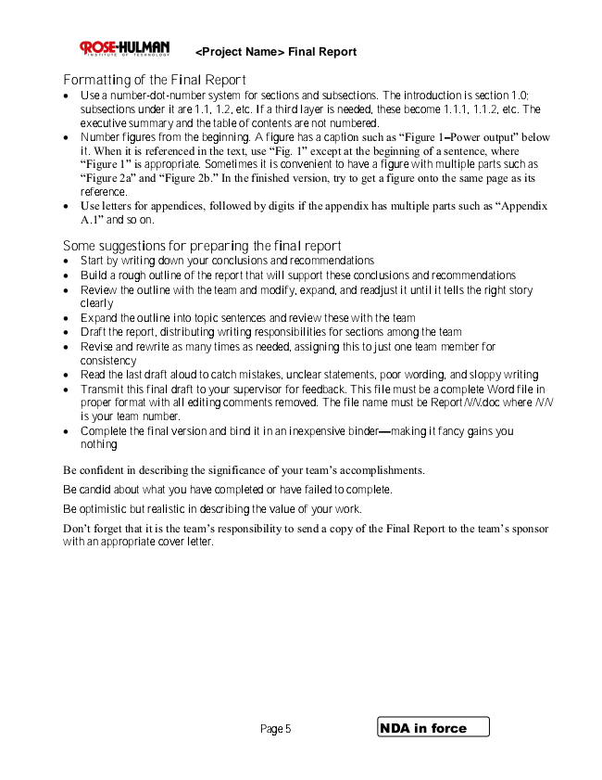

**<Project Name> Final Report**

**Formatting of the Final Report**

• Use a number-dot-number system for sections and subsections. The introduction is section 1.0; subsections under it are 1.1, 1.2, etc. If a third layer is needed, these become 1.1.1, 1.1.2, etc. The executive summary and the table of contents are not numbered.

• Number figures from the beginning. A figure has a caption such as “Figure 1–Power output” below it. When it is referenced in the text, use “Fig. 1” except at the beginning of a sentence, where “Figure 1” is appropriate. Sometimes it is convenient to have a figure with multiple parts such as “Figure 2a” and “Figure 2b.” In the finished version, try to get a figure onto the same page as its reference.

• Use letters for appendices, followed by digits if the appendix has multiple parts such as “Appendix A.1” and so on.

**Some suggestions for preparing the final report**

• Start by writing down your conclusions and recommendations

• Build a rough outline of the report that will support these conclusions and recommendations

• Review the outline with the team and modify, expand, and readjust it until it tells the right story clearly

• Expand the outline into topic sentences and review these with the team

• Draft the report, distributing writing responsibilities for sections among the team

• Revise and rewrite as many times as needed, assigning this to just one team member for consistency

• Read the last draft aloud to catch mistakes, unclear statements, poor wording, and sloppy writing

• Transmit this final draft to your supervisor for feedback. This file must be a complete Word file in proper format with all editing comments removed. The file name must be ReportNN.doc where NN is your team number.

• Complete the final version and bind it in an inexpensive binder—making it fancy gains you nothing

Be confident in describing the significance of your team’s accomplishments. Be candid about what you have completed or have failed to complete.

Be optimistic but realistic in describing the value of your work. Don’t forget that it is the team’s responsibility to send a copy of the Final Report to the team’s sponsor with an appropriate cover letter.

Page 5 NDA in force